Local Dynamics and the Holocaust

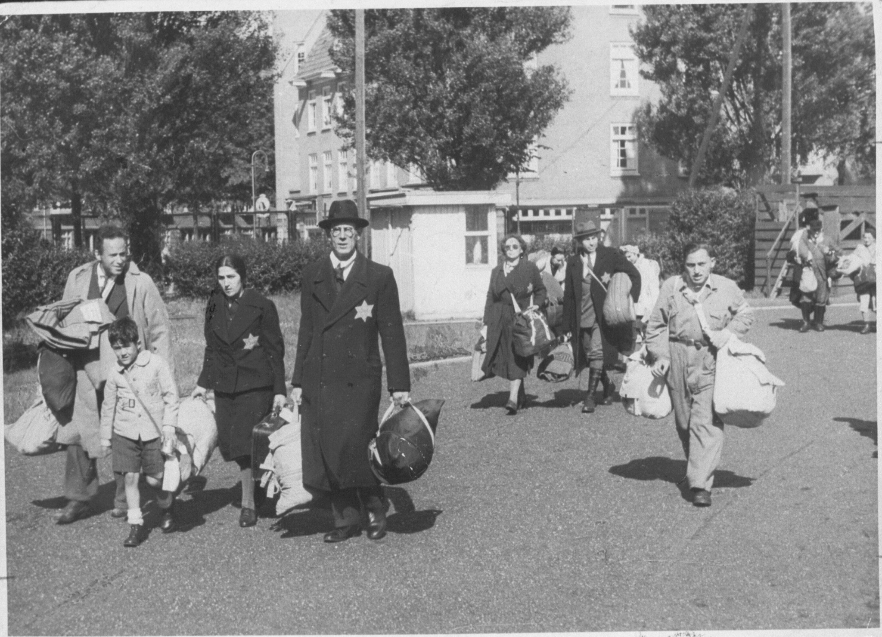

Amsterdam, 20 June 1943: Forced departure to the transit camp of Westerbork (photograph by Herman Heukels)

Utrecht University June 2024

 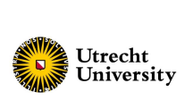

**Program**

Location:

June 10: UU, Kromme Nieuwegracht 80, room 1.06

June 11: ICU, Kriekenpitplein 1, Spinoza Hall, room 2.05

Mobile nrs of the organizing team: +31(0)62556742 (Otto),+31(0)615094789 (Geraldien), +1(631)5602707 (Catharine)

**Short Description**

The Holocaust is one of the best researched major episodes of mass destruction in modern Western history. Whereas the scholarship initially merely focused on German policy makers and decision takers, perceiving the Holocaust as a story of Nazi perpetrators and Jewish victims, today there is general agreement that the genocide should (also) be studied in its local, communal embedment. The numerous small-scale studies of recent years, often of individual towns, show that the Holocaust affected local communities tremendously. At the same time they shed light on the involvement of ‘native’ local elites, authorities, and institutions, and lay bare a wide specter of Jewish and Gentile reactions from within the local population. From these studies it becomes evident that the specific pre-existing structures in a town could impact the course of the genocide on the spot.

The findings in these individual case studies support Omer Bartov’s notion of ‘communal genocide’ (Bartov 2019). What is still lacking, however, is a more comparative and comprehensive analysis of this notion. What are precisely those pre-existing structures in local society that impacted the course of the genocide? Which local dynamics were at play during the Holocaust and, in a wider timeframe, how were they affected by the Holocaust? How did local political figures influence the course and pace of the genocide in their community, and why? How did local civil society react to the incessant stream of anti-Jewish measures? How did the targeting of one group of citizens change the local civil society, during and after the events? These and similar questions have not yet been addressed systematically.

The aim of our seminar is to explore the feasibility of a more systematic analysis of the notion of ‘communal genocide’ as introduced by Bartov. We invite scholars of cutting-edge research in the emerging subfield of ‘communal genocide’ to reflect on the ways local dynamics and the Holocaust in their town of study interacted. The seminar will be organized around three central issues:

- The Holocaust and local stability in the longue durée

- Collusion and alliance of local political actors and central authorities

- Civil society organizations and the Holocaust

**MONDAY JUNE 10**

**13:15 – 14:00 Arrival of guests, meet and greet**

**14:00 – 14:30 Presentation of the organizing team, the NWO-project The Holocaust in the Dutch Provinces: Local Dynamics in the Nazi-Occupied Netherlands, and the goals of the seminar**

**14:30 – 16:30 Session 1: Local Political Actors (moderator: Geraldien von Frijtag)**

*How were local political actors and institutions woven into the infamous ‘machinery of destruction’ and how did they shape/how were they shaped by participation in the Holocaust? This panel seeks to identify and contextualize local political actors and institutions that impacted the course of the genocide in their local environments. It further seeks to demonstrate how studying these actors and institutions can provide a deeper understanding of the Holocaust both within and beyond local contexts.*

* Administrative Continuity and the Role of Local Political Actors in Shaping the Holocaust: A Comparative Microhistory of the Holocaust in Roermond and Meppel 1930-1945 - Catharine Aretakis (Utrecht University)
* The “Jewish Department” of the Police Headquarters in Prague and its Role in the “Solution to the Jewish Question” in the Protectorate of Bohemia and Moravia - Jan Dvorak (The Institute for the Study of Totalitarian Regimes Prague)
* A Blueprint for Genocide in the Independent State of Croatia? Local Elites, Antisemitism, and Decision-Making during the Holocaust in the Town of Križevci - Lovro Kralj (University of Rijeka)

**17:00 Key-note prof.dr. Mary Fulbrook (University College London)**

**Address: Muntstraat 2A, Room T.0.05**

**Surrounding societies and Holocaust survival: Comparative perspectives**

Jewish survival chances across Europe during the Holocaust varied significantly according to region, time, and arena of warfare. The high rate of deportations and deaths of Jews from the Netherlands, for example, is an outlier in western Europe, differing markedly from neighbouring France and Belgium, and more akin to the high death rates in eastern European countries such as Poland, Lithuania and Latvia. There have been numerous controversies in attempts to explain differing survival rates, including around what members of local societies ‘knew’, degrees of pre-existing antisemitism, the character of German and local power structures, and the instruments of control and repression. Within this wider historiographical context, this paper focuses specifically on the significance of surrounding societies for survival, looking from the perspectives of both victims and non-Jewish members of local populations. Exploring examples from different areas in both Eastern and Western Europe, the paper addresses not only the complexities of local dynamics during the war, as these affected patterns of persecution, but also the enduring significance of wartime experiences for later constructions of identity and representation. Comparisons based on a selection of contemporary sources, later memoirs, self-representations, and public exhibits, in the context of the wider historiographical debates, may contribute to identifying the significance of surrounding societies for the dynamics of persecution and its representation both at the time and later.

**18:30 Drinks**

**19:00 Diner**

**TUESDAY JUNE 11**

**9:30 – 10:00 Coffee and tea**

**10:00 – 12:00 Session 2: Jewish Agency (moderator: Laurien Vastenhout)**

*This session will look at Jewish reactions to persecution, on the level of the individual and collective, unorganized and organized. How did Jews react to the violence, in all its different shapes? How did they make sense of the events? How did local specificities impact their experiences and perceptions, their choices of strategies to evade the persecution?*

* “Say *kukuruza”*: Language Skills and Jewish Survival in Nazi-Occupied Ukraine - Tobias Wals (Leibniz Institute for Contemporary History)
* ‘A Comparative Case of Two Councils’: Investigating the Attitude of the Jewish Councils of Zwolle and Enschede during the Second World War - Meta Huijsmans (NIOD Institute for War, Holocaust and Genocide Studies)
* Jewish Intelligentsia in the Ghetto of Tomaszów Mazowiecki - Justyna Biernat (Adjutant at the Polish Academy of Sciences and the Spaces of Memory Foundation)
* The “Ghastly Decade” (1936-1946) in the Town of Nowy Targ - Karolina Panz (Polish Center for Holocaust Research)

**12:00 – 13:15 Lunch**

**13:15 – 15:00 Session 3: Local Communities (moderator: Dienke Hondius)**

*This session will explore the way local societies evolved under the stress of occupation and genocide. How “communal” was the Holocaust in different towns across the map of occupied Europe? How did non-Jews react to the introduction of rules that targeted only their Jewish fellows, and how were their relations with their Jewish fellows affected?*

* The Wide Gamut of Response(s) that Athenian Civil Society Exhibited in the Face of the Persecution of Native and Refugee Jews in Athens (1943-1944) - Philip Carabott (King’s College London)
* Forced Homes: An Examination of the System of Forced Accommodation in Nazi Berlin and Life within it - Bethan Griffiths (Aktives Museum Faschismus und Widerstand in Berlin)
* The Holocaust in Kampen: The Paradoxes of Resistance, Indifference, and Rescue Efforts in a Dutch Provincial City - George Harinck (Theological University Utrecht) and Dr. Andrew Kloes (United States Holocaust Memorial Museum, Washington D.C.)
* Operation Rheinhardt in the Provincial Ghettos of the Warsaw District 1942-1943 - the Example of the Minsk-Mazovia Poviat - Joanna Nikel (Center for Totalitarian Studies Pilecki Institute, Warsaw)

**15:00 – 15:15 Tea**

**15:15 - 17:00 Session 4: Longue durée (moderator: Philip Carabott)**

*This panel is founded on the acknowledgment that the Holocaust did not exist in a historical vacuum and that the course of the Holocaust, especially at the local level, was greatly influenced by pre-existing dynamics developed years prior to the outbreak of the Second World War. The papers presented analyze key local dynamics that shaped the genocide in their communities over many years including into the aftermath of the violence. Such analysis allows for the study of the evolution and entanglement of local dynamics and the Holocaust.*

* Crimean Citizens between Nazi Occupiers and Soviet Liberators: Dynamics of Relations in Local Communities during and after the Holocaust - Irina Makhalova (Humboldt University of Berlin)
* A Dual Approach to Local Police Involvement in the Holocaust - Laura Brinkhorst and Lieke Speerstra (Radboud University Nijmegen)
* Dimensions of Continuity under the New Order? Participation of the Municipal Administration in the Implementation of Nazi Policies in Occupied Poland - Franek Zakrzewski (School for Advanced Studies in the Social Sciences Paris)
* The Holocaust in Rural Wallonia, Belgium: Local Dynamics or The Case For Civil Society - Jan Burzlaff (Harvard University)

**17:00 – 18:00 Wrapping up**